Normal
- [List, Arrays] Reverse Array. Given an array, reverse it.
- [List, Arrays] Binary search. Write recursive and iterative versions of a binary search in an array.
- [List, Arrays] Intersection of arrays. Given 2 arrays find an intersection of them.
Example:
A [1 2 3 4] B [5 6 7 8] Res = []
A [1 2 3 4] B [ 1 4 8 10] Res = [1 4]
- [List, Arrays] Shuffle. Without using a shuffle or sort write your own shuffle method for an array. You can use a random number generator. The method will take an array and return a new array with all of the elements in a random order. One important property of a good shuffle method is that every permutation is equally likely.
- [List, Arrays] Shift Array Rotate an array by k positions.
Example: A [1 2 3 4 5 6] k = 3 Res = [4 5 6 1 2 3]
- [String] Pig Latin. Write a method the takes in a string and returns the pig latin equivalent. Pig Latin takes the first consonant, moves it to the end of the word and places “ay” at the end. If the string starts with a vowel do nothing. “pig” -> “igpay”, “banana” -> “ananabay”, “egg” -> “egg”
- [String] Anagrams. Write a method to decide if two strings are anagrams or not. An anagram is a word formed by rearranging the letters of another word, e.g., iceman is an anagram of cinema.
- [String] Palindrome. Determine if a given string is a palindrome. A palindrome is a string that is the same forwards as backwards, ignoring letter case, punctuation marks and word dividers. For example, “racecar” and “Amor, Roma” are palindromes, “abcd” is not. We limit the punctuation marks to ignore by the period, comma, question mark, exclamation point, apostrophe, colon, semicolon and hyphen.
- [String] Reverse String. Write code to reverse a C-Style String. (C-String means that “abcd” is represented as five characters, including the null character.)
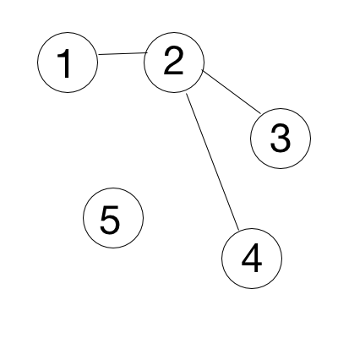
- [String] Finding Duplicates. Print out the duplicate elements in a given string.
- [Graph] Roads Count. In Milky Way galaxy there is a planet Neptune with N cities. Some of them are connected with roads. You need to print out a count of roads by given adjacency matrix. Input: 1st row - N, number of cities, next N rows - adjacency matrix.
Input: Output:
5 3
0 1 0 0 0
1 0 1 1 0
0 1 0 0 0
0 1 0 0 0
0 0 0 0 0
- [Graph] Find a ring road. You need to print “Ring road” if there are roads that make a ring road, “Tree structure” - otherwise. Input: 1st row - N, number of cities, next N rows - adjacency matrix.
Input: Output: Input: Output:
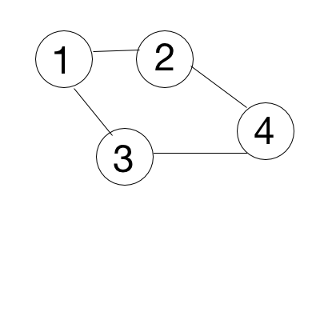
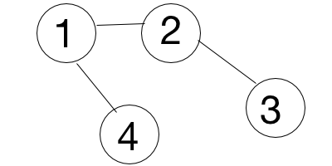
4 Ring road 4 Tree structure
1 1 1 0 1 1 0 1
1 1 0 1 1 1 1 0
1 0 1 1 0 0 1 0
0 1 1 1 1 0 0 1
- [Graph] Is there another country? If two cities are connected, they belong to the same country. You need to check if there is only one country on a planet. Print YES - if only one, NO - otherwise. Input: 1st row - N, K, where N - number of cities, K - number of roads, next K rows - adjacency list.
Input: Output: Input: Output: Input: Output:
5 4 YES 1 0 YES 5 2 NO
1 2 1 2
3 4 4 5
5 2
4 5
- [DP] The Fibonacci numbers. Write a function that returns $$F_{n}$$.
In mathematical terms, the sequence Fn of Fibonacci numbers is defined by the recurrence relation with seed values $$F_{n}= F_{n-1}+F_{n-2}$$ with $$F_{0}= 0$$ and $$F_{1}= 1.$$
0, 1, 1, 2, 3, 5, 8, 13, 21, 34, 55, 89, 141, ……..
Input: 3 Output: 2 Input: 10 Output: 55
- [DP] Making change. Given an infinite number of quarters (25 cents), dimes (10 cents), nickels (5 cents) and pennies (1 cent). Write a code to calculate the number of ways of representing n cents.
Input: 3 Output: 1 (1+1+1) Input: 10 Output: 4 (10, 5+5, 5+1+1+1+1+1, 1+1+..+1+1)
- [DP] Maximum Subarray. Find the contiguous subarray within an array (containing at least one number) which has the largest sum.
Input: [−2,1,−3,4,−1,2,1,−5,4] Output: 6 ([4,−1,2,1])
- [Linked List] Reverse List In Place. Implement the reversal of a singly linked list. You should be able to do this in linear time and without allocating additional memory other than pointers.
- [Linked List] Insert Elements. Insert an element in order into a sorted linked list containing integers.
- [Linked List] Linked List Cycle. Given a linked list, determine if it has a cycle in it.
- [Linked List] Merge Sorted Lists. Merge two sorted linked lists and return it as a new sorted list. The new list should be made by splicing together the nodes of the first two lists.
Example: Input A: 5 -> 10 -> 15 B: 2 -> 3 -> 20 Result: 2 -> 3 -> 5 -> 10 -> 15 -> 20
Note: There are many cases to deal with: either list ‘a’ or list ‘b’ may be empty, during processing either list ‘a’ or list ‘b’ may run out first, and finally there’s the problem of starting the result list empty, and building it up while going through lists ‘a’ and ‘b’.
- [Linked List] Intersection of Lists. Given two different lists of objects, come up with an efficient solution to find the intersection of the two lists.
Example: Input A: 10->15->4->20 B: 8->4->2->10 Result: 4->10
- [Queue, Stack] Design a queue using an array. Develop the push | pop | peek | isEmpty functions for a queue using an array as the internal data structure.
- [Queue, Stack] Implement two stacks in an array. Create a data structure twoStacks that represents two stacks. Implementation of twoStacks should use only one array, i.e., both stacks should use the same array for storing elements. Following functions must be supported by twoStacks.
push1(int x) –> pushes x to first stack
push2(int x) –> pushes x to second stack
pop1() –> pops an element from first stack and return the popped element
pop2() –> pops an element from second stack and return the popped element
- [Queue, Stack] Balanced parentheses. Write a function which checks if parentheses in a given expression are balanced.
Example: 1) input: (5+6)*(7+8)/(4+3) output: balanced
2) input: (4+5)*(2+(4-7) output: not balanced
- [Queue, Stack] Postfix expression Given an expression in postfix notation evaluate it. In postfix notation operands are followed by operations. For example, X+Y becomes XY+ in postfix notation. Example: 1) input: 5 6 + output: 11 2) input: 23 17 + 45 5 - - output: 0
- [Queue, Stack] Permutations. Print all permutations of N elements in an array.
- [Queue, Stack] Combinations. Print all combinations of N elements in an array (each element is chosen at most once in any combination).
- [Queue, Stack] Find moving averages and maximums. Given an infinite stream of numbers in time order, at any given time:
- Find moving averages of the last K numbers.
- Find the maximums of the last K numbers (maybe medium problem)
- [Binary Tree] Pre-post-In Traversal. Print pre-, post- and in-order traversal output for the binary tree.
- [Binary Tree] Balanced Tree. Implement a function to check if a tree is balanced. Balanced tree is a tree such that no two leaf nodes differ in distance from the root by more than one.
- [Binary Tree] Verify BST. Given the root of a binary tree, verify whether the tree is a binary search tree.
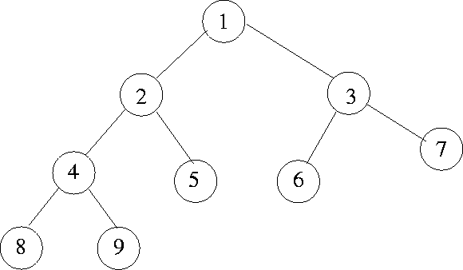
- [Binary Tree] Breadth First Search. Implement a breadth first search algorithm recursively and iteratively for a binary tree.
- [Binary Tree] Lowest common ancestor in BT (not BST). Given two values that already exist in a binary tree, find the lowest common ancestor.
Example: For this tree, common ancestor for nodes 8 and 5 is node 2
- [Binary Tree] Get Level of a node in a Binary Tree. Level of a node is distance from root to that node. Given a Binary Tree and a key, write a function that returns level of the key.
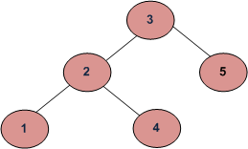
Example, consider the following tree. If the input key is 3, then your function should return 0. If the input key is 4, then your function should return 2. And for key which is not present, then return -1.
- [Binary Tree] Finding Kth smallest element in binary search tree. You are given a binary search tree and you are asked to find the Kth smallest element in that tree.

